Comenzi utile

http://www.adresameaip.ro/comenzi-ip.php
Comenzi IP din lina de comanda (CMD - command)
Pentru a accesa linia de comanda din Windows XP click pe Start, selecteaza Run si in casuta ce apare scrie cmd, apoi apasa Enter. Daca nu dispui de optiunea RUN, contacteaza administratorul retelei/calculatorului.
- Afisare configurare conexiune (Display Connection Configuration): ipconfig /all
- Afisare cache DNS (Display DNS Cache Info Configuration): ipconfig /displaydns
- Curatare cache DNS (Clear DNS Cache): ipconfig /flushdns
- Terminarea tuturor conexiunilor IP (Release All IP Address Connections): ipconfig /release
- Reinoirea conexiunilor IP (Renew All IP Address Connections): ipconfig /renew
- Re-inregistreaza conexiunile DNS (Re-Register the DNS connections): ipconfig /registerdns
- Afisare informatii clasa DHCP (Display DHCP Class Information): ipconfig /showclassid
- Schimba/Modifica DHCP class ID (Change/Modify DHCP Class ID): ipconfig /setclassid
- Conexiuni retea (Network Connections): control netconnections
- Setare retea (Network Setup Wizard): netsetup.cpl
- Testare conexiune (Test Connectivity): ping www.adresamea.ro
- Trasare ruta IP (Trace IP address Route): tracert www.adresamea.ro
- Afisare sesiuni TCP/IP (Displays the TCP/IP protocol sessions): netstat
- Afisare ruta locala (Display Local Route): route
- Afisare adresa MAC (Display Resolved MAC Addresses): arp
ARP vine de la Address Resolution Protocol
- Afisare nume calculator (Display Name of Computer Currently on): hostname
- /? - utilizat dupa comenzi iti va afisa sectiunea de Ajutor privind comanda respectiva.

Pagina principala |  | Curs | Laborator | Proiect

Verificare servicii >>
In acest laborator va vor fi prezentate cateva comenzi care va ajuta sa verificati:
- daca un calculator are setarile necesare pentru a avea acces in Internet
- daca un server sau host de pe Internet este in functiune si daca ruleaza un anumit serviciu
Setarile calculatorului (a placii de retea)
Primul lucru care se poate verifica daca conexiunea la Internet a unui calculator nu functioneaza este daca are setarile necesare (pe care le obtineti de la ISP sau administratorul ed retea), adica:
- adresa IP
- default gateway, care este nodul urmator la care este trimis orice pachet pentru a fi transmis mai departe
- server DNS: adresa IP a serverului care rezolva maparea intre numele de domeniu si adresa IP corespunzatoare
In Windows acest lucru il puteti face cu comanda ipconfig (executat din linia de comanda - Command Prompt), care va arata adresa IP si gateway-ul, dupa cum puteti vedea si mai jos:
Ethernet adapter RTL81391:
IP Address. . . . . . . . . : 192.168.5.16
Subnet Mask . . . . . . . . : 255.255.255.0
Default Gateway . . . . . . : 192.168.5.254
Pentru a vedea si adresa DNS al serverului de la care se face interogarea adreselor IP, comanda este:
ipconfig /all
iar rezultatul este cel de jos:
Host Name . . . . . . . . . : dtk56.unitbv.ro
DNS Servers . . . . . . . . : 193.254.231.2
193.254.230.1
Node Type . . . . . . . . . : Broadcast
NetBIOS Scope ID. . . . . . :
IP Routing Enabled. . . . . : No
WINS Proxy Enabled. . . . . : No
NetBIOS Resolution Uses DNS : No
Ethernet adapter RTL81391:
Description . . . . . . . . : NDIS 4.0 driver
Physical Address. . . . . . : 00-20-18-8D-B4-94
DHCP Enabled. . . . . . . . : No
IP Address. . . . . . . . . : 192.168.5.16
Subnet Mask . . . . . . . . : 255.255.255.0
Default Gateway . . . . . . : 192.168.5.254

In Linux comanda pentru aflarea adresei IP la care este setata placa de retea este:
ifconfig
Ping & traceroute
Comanda ping este folosita pentru a afla daca un calculator este sau nu in functiune, insa nu da nici o alta informatie relevanta despre ce servicii sunt disponibile pe calculator (server web, mail, etc.) Aceasta comanda trimite pachete mici de 56 octeti catre destinatie si daca aceasta este in functiune, va primi raspuns la pachetele trimise. Exemplu de mai jos arata efectul comenzii:
ping www.rds.ro
C:\> ping www.rnc.ro
PING www.rnc.ro (193.230.31.221) from 193.230.54.35 : 56(84) bytes of data.
64 bytes from webvir.rnc.ro (193.230.31.221): icmp_seq=0 ttl=251 time=17.201 msec
64 bytes from webvir.rnc.ro (193.230.31.221): icmp_seq=1 ttl=251 time=21.277 msec
64 bytes from webvir.rnc.ro (193.230.31.221): icmp_seq=2 ttl=251 time=38.692 msec
64 bytes from webvir.rnc.ro (193.230.31.221): icmp_seq=3 ttl=251 time=49.086 msec
64 bytes from webvir.rnc.ro (193.230.31.221): icmp_seq=4 ttl=251 time=17.119 msec
64 bytes from webvir.rnc.ro (193.230.31.221): icmp_seq=5 ttl=251 time=17.092 msec
64 bytes from webvir.rnc.ro (193.230.31.221): icmp_seq=6 ttl=251 time=17.215 msec
64 bytes from webvir.rnc.ro (193.230.31.221): icmp_seq=7 ttl=251 time=44.197 msec
64 bytes from webvir.rnc.ro (193.230.31.221): icmp_seq=8 ttl=251 time=17.111 msec
--- www.rnc.ro ping statistics ---
9 packets transmitted, 9 packets received, 0% packet loss
round-trip min/avg/max/mdev = 17.092/26.554/49.086/12.634 ms
In acest caz pachetele se trimit catre destinatie pana cand se intrerupe executia comenzii cu CTRL-C. Se poate specifica numarul de pachete trimise pentru a testa destinatia. Sub Windows comanda in acest caz este:
ping -n 5 www.rnc.ro
unde s-a indicat cu optiunea -n cate pachete sa fie trimise.
ATENTIE: Atat la ping cat si la traceroute este posibil ca firewall-ul sistemului de la destinatie sa interzica asemenea pachete, deci testarea in acest mod a functionalitatii serverului este ineficienta. Daca acestea nu dau nici un rezultat se poate testa functionarea unui anumit serviciu pe server-ul respectiv. A se vedea testarea prin telnet in sectiunea urmatoare.
Traceroute este comanda care arata ruta catre o anumita destinatie, deci nodurile prin care trec pachetele catre destinatie. Este util atunci cand aveti posibilitatea sa accesati o informatie pe mai multe servere prin site-uri mirror, si daca aveti servere mirror in Romania si Germania de exemplu, nu este sigur ca serverul din Romania este mai aproape ca numar de noduri si ca intarziere de transmisie a pachetelor decat cel din Germania. Depinde prin ce ISP este facuta legatura Internet. Stiind pe ce ruta trec pachetele puteti accesa serverul care este mai aproape.
De asemenea este util atunci cand nu se poate face conexiunea catre un anumit server pentru a se verifica in ce loc este intrerupta legatura. Comanda in Linux este:
traceroute nume_domeniu_destinatie
iar sub Windows este tracert. De exemplu un traceroute catre www.kappa.ro:
orion:~$ traceroute www.kappa.ro
traceroute to www.kappa.ro (194.102.255.4), 30 hops max, 38 byte packets
1 vega (193.230.54.35) 0.356 ms 0.240 ms 0.208 ms
2 gw1 (193.230.54.1) 4.263 ms 4.131 ms 4.192 ms
3 s4-1-2.3662.rnc.ro (193.230.52.121) 14.165 ms 13.840 ms 53.993 ms
4 eth0-1-gw.buhix.ro (193.230.52.30) 21.040 ms 26.705 ms 15.121 ms
5 route-server.iex.ro (194.102.255.254) 24.046 ms 18.315 ms 71.857 ms
6 www.kappa.ro (194.102.255.4) 22.157 ms 25.201 ms 60.437 ms
Observati: se afla intai adresa IP de la serverul DNS si pe baza IP-ului se face cautarea rutei.
Traceroute este posibil si prin cateva pagini web, caz in care se afla numarul de noduri (hop-uri) de la acel server web pana la destinatia dorita. De obicei este utilizata pentru a vedea daca un server este in functiune, sau pentru a vedea unde pe ruta catre destinatie unde se opresc pachetele, deci unde sunt probleme. Una din aceste adrese este:
http://www.traceroute.org
unde se poate selecta ca traceroute sa fie efectuat dintr-o anumita tara.
Alta adresa de la care se pot face traceroute:
http://www.belnet.be/cgi-bin/traceroute
Verificare servicii >>
Verificare servicii
Pagina principala |  | Curs | Laborator | Proiect

<< Traceroute | Interogare server DNS >>
In cazul in care se doreste verificarea functionarii unui anumit serviciu pe un server metoda cea mai sigura este de a va conecta pe portul specific acelui serviciu. Porturile standard pentru cele mai folosite servicii in Internet sunt:
Port | Serviciu
23 | telnet
25 | mail
80 | http
21 | ftp
110 | pop3
...
Verificarea serviciului se poate face cu ajutorul comenzii telnet, specificand ca al doilea parametru numarul portului la care se doreste conectarea. In exemplul de mai jos aveti raspunsul primit ca urmare a comenzii de conectare la portul 80:
telnet vega.unitbv.ro 80
orion:~$ telnet vega.unitbv.ro 80
Trying 193.254.231.35...
Connected to vega.unitbv.ro.
Escape character is '^]'.
Mai departe serverul asteapta o comanda a protocolului HTTP de cerere a unui fisier. Inchiderea unei conexiuni telnet se poate face mereu cu combinatia CTRL-].
Daca in continuare s-ar da comanda de cerere a unei pagini web, serverul va transfera fisierul html respectiv, exact cum o face cand comunica cu navigatorul. De exemplu:
telnet vega.unitbv.ro 80
Trying 127.0.0.1...
Connected to vega.unitbv.ro.
Escape character is '^]'.
GET /~jipa/ui/index.html HTTP/1.1
Nu uitati: Trebuie sa introduceti un ENTER dupa tastarea comezilor (indicat cu bold) si inca un ENTER pentru a indica serverului web ca s-a trimis cererea si se asteapta raspunsul.
La fel se poate verifica si functionarea serverului de mail:
orion:~$ telnet vega.unitbv.ro 25
Trying 193.230.54.35...
Connected to vega.unitbv.ro.
Escape character is '^]'.
220 vega.unitbv.ro ESMTP Sendmail 8.11.2/8.11.2; Sun, 24 Nov 2002 19:56:58 +0200
In exemplul de mai sus se poate vedea ca a raspuns serverul de mail (Sendmail), si s-a precizat versiunea acestuia.
La fel se poate proceda si in cazul altor servicii: ftp, ssh, pop3 etc.
In Linux porturile corespunzatoare diferitelor servicii se gasesc in fisierul /etc/services.
<< Traceroute | Interogare server DNS >>
Nslookup, dig. Whois
Pagina principala |  | Curs | Laborator | Proiect

<< Verificare servicii | Exercitii >>
Pentru aflarea adresei IP a unui host pe baza numelui de domeniu sau IP-ul corespunzator unui nume de domeniu se foloseste comanda nslookup, atat sub Linux cat si Windows. Acesta interogheaza serverul DNS a carei adresa IP este setat pe calculatorul local.
Observatie: se poate intra in programul nslookup
- dand ca parametru numele de domeniu al serverului caruia vrem sa-i aflam numele
- se tasteaza numai numele programului nslookup, dupa care apare prompter-ul programului >, din care se poate iesi cu comanda exit (vezi exemplul 2 de mai jos).
De exemplu pentru aflarea IP-ului serverului www.unitbv.ro, se da comanda ca mai jos:
orion:~$ nslookup www.unitbv.ro
Note: nslookup is deprecated and may be removed from future releases.
Consider using the `dig' or `host' programs instead. Run nslookup with
the `-sil[ent]' option to prevent this message from appearing.
Server: 193.254.231.2
Address: 193.254.231.2#53
Non-authoritative answer:
www.google.com canonical name = www.google.akadns.net.
Name: www.google.akadns.net
Address: 66.102.11.99
Se vede in exemplul de sus adresa IP al serverului care a facut interogarea 193.254.231.2, adica serverul DNS de pe colina. Acesta va da raspunsul primit, adica numele de domeniu si IP-ul corespunzator.
Cautare inversa: din adresa IP -> numele de domeniu.
orion:~$ nslookup
> 200.128.23.214
Server: 193.254.231.2
Address: 193.254.231.2#53
Non-authoritative answer:
214.23.128.200.in-addr.arpa name = admnet01.adm.ufba.br.
Authoritative answers can be found from:
200.in-addr.arpa nameserver = DILL.ARIN.NET.
200.in-addr.arpa nameserver = BUCHU.ARIN.NET.
200.in-addr.arpa nameserver = ARROWROOT.ARIN.NET.
200.in-addr.arpa nameserver = NS.DNS.br.
200.in-addr.arpa nameserver = NS.LACNIC.ORG.
200.in-addr.arpa nameserver = NS2.DNS.br.
200.in-addr.arpa nameserver = CHIA.ARIN.NET.
NS.DNS.br internet address = 200.160.0.5
NS.LACNIC.ORG internet address = 200.160.0.7
NS2.DNS.br internet address = 200.19.119.99
CHIA.ARIN.NET internet address = 192.5.6.32
DILL.ARIN.NET internet address = 192.35.51.32
BUCHU.ARIN.NET internet address = 192.100.59.110
ARROWROOT.ARIN.NET internet address = 198.133.199.110
>exit
orion:~$
In cazul in care serverul DNS nu functioneaza, primiti un raspuns ca mai jos:
nslookup
Note: nslookup is deprecated and may be removed from future releases.
Consider using the `dig' or `host' programs instead. Run nslookup with
the `-sil[ent]' option to prevent this message from appearing.
> www.yahoo.com
;; connection timed out; no servers could be reached
> exit
orion:~$
Sub Linux exista si comanda dig care ofera mai multe informatii despre numele de domeniu.
Exemplul de mai jos este primit ca raspuns la comanda:
dig www.unitbv.ro
; <<>> DiG 9.2.1 <<>> www.unitbv.ro
;; global options: printcmd
;; Got answer:
;; ->>HEADER<<- opcode: QUERY, status: NOERROR, id: 53041
;; flags: qr aa rd ra; QUERY: 1, ANSWER: 2, AUTHORITY: 0, ADDITIONAL: 0
;; QUESTION SECTION:
;www.unitbv.ro. IN A
;; ANSWER SECTION:
www.unitbv.ro. 86400 IN CNAME webe.unitbv.ro.
webe.unitbv.ro. 86400 IN A 193.254.230.102
;; Query time: 35 msec
;; SERVER: 193.254.231.2#53(193.254.231.2)
;; WHEN: Tue Dec 2 12:38:00 2003
;; MSG SIZE rcvd: 66
Whois
Cautarea inregistrarii unui nume de domeniu, se face prin serviciul whois
Whois pentru TLD-ul .ro
De exemplu puteti face o cautare pentru domeniul unitbv.ro sau un alt domeniu care va intereseaza.
Exemplul de mai jos arata inregistrarea domeniului unitbv.ro:
domain-name: unitbv.ro
description: University TRANSILVANIA of Brasov
admin-contact: RI19-ROTLD
technical-contact: RI19-ROTLD
zone-contact: RI19-ROTLD
nameserver: ns.unitbv.ro 193.230.54.2
nameserver: ns-a.rnc.ro 192.162.16.21
info: object maintained by ro.rnc local registry
info: Register your .ro domain names at www.rotld.ro
info: the object is maintained by ro.rnc registry
notify: domain-admin@listserv.rnc.ro
object-maintained-by: ROTLD-MNT
mnt-lower: ROTLD-MNT
updated: estaicut@rnc.ro 19991206
updated: peter@rnc.ro 20000524
source: ROTLD
application-date: 19940831
domain-status: active
registration-date: 19940807
person: Radu IONESCU
address: University TRANSILVANIA Brasov
address: Bvd. Eroilor No. 29
address: 2200 Brasov
address: Romania
phone: +40 68 472 564
fax-no: +40 68 144 634
e-mail: iradu@unitbv.ro
nic-hdl: RI19-ROTLD
notify: domain-admin@listserv.rnc.ro
object-maintained-by: ROTLD-MNT
updated: domain-admin@listserv.rnc.ro 19961223
source: ROTLD
Pentru domeniile .com, .edu etc. cautarea se poate face la:
Whois pentru domeniile .com .edu .mil ...
De exemplu incercati o cautare pentru uoregon.edu.
Iar la aceasta adresa se poate face cautare pentru domeniile din TLD-rile care contin codul tarii.
Whois in celelalte TLD-uri
<< Verificare servicii | Exercitii >>
Exercitii
Pagina principala |  | Curs | Laborator | Proiect

<< Interogari DNS

1. Verificati daca pe serverul leda.unitbv.ro ruleaza serviciile web, ftp si mail. Care servicii sunt disponibile?
2. Verificati care domeniu detine adresa IP 193.226.140.242
3. Verificati inregistrarea DNS pentru domeniile pub.ro si snowboard.ro Cine detine domeniile si unde sunt gazduite?
4. Care este serverul mail pentru domeniul unitbv.ro? Care este adresa IP al acestui server? Ce comanda ati utilizat pentru a afla informatiile?

http://www.techexams.net/technotes/networkplus/tcpiputils.shtml

Network+ TechNote: TCP/IP utilities
Members-only Printer-friendly version
Note: not all parameter and switches are decribed in this TechNote, just those of improtance for the Network+ exam. If you want more information about a particular utility type use the command with a /? switch. Try these commands on your own PC when you're preparing for the Network+ exam.
Tracert
Tracert is a Windows command-line utility that uses ICMP Echo packets and their TTL (Time To Live) value to determine the route and hopcount to a destination. In the following network for example, when a connection between host A and B fails, you can use tracert to find out where the packet stopped.
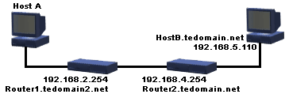
The following image shows the output of running tracert 192.168.5.110 on host A.
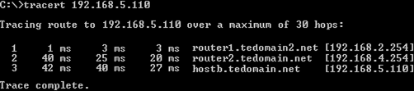
The target can be either a name or an IP address. By default, tracert will try to resolve the IP address of every hop (router) along the path to a hostname. To prevent this, and possibly speed up the tracing process, you can use the –d option as displayed in the following image:
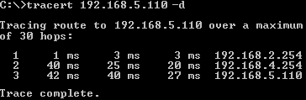
The Unix/Linux counterpart of tracert is traceroute, which basically provides the same functionality as tracert does for Windows systems. However, traceroute offer several additional command-line options to give you more control, such as specifying the gateway or source IP address. Traceroute uses UDP packets by default instead of ICMP packets.

PING
The ping utility is a diagnostic tool that you can use to test TCP/IP configurations and connections. It is useful to determine whether a particular TCP/IP host can be reached and is available. The syntax for the ping command is:
ping target
target can be either a name (hostname or NetBIOS name) or an IP address. The following image shows the output of running the command ping www.techexams.net
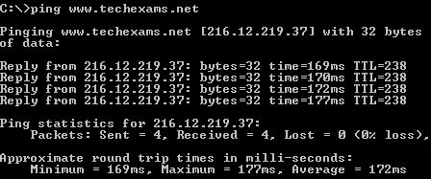
Some common situations where PING can be useful:
- To verify that TCP/IP is installed, initialized, and bound to your network interface, ping the loopback address (ping 127.0.0.1).
- To verify that the default gateway is available and the computer can communicate with a remote host through a router, ping a host on a remote network.
- To verify that DNS host name resolution is available, ping an existing host name of a computer you know is online and available.
- To verify that WINS name resolution is available, ping an existing NETBIOS name, of a computer you know is online and available.
ARP
As described in the TCP/IP Suite TechNotes, the Address Resolution Protocol (ARP) is used for resolving layer 3 IP addresses to layer 2 MAC addresses. The corresponding utility arp can be used to manually resolve an IP address to a MAC addresses and to modify or display the current ARP cache table. Below is an example output of using arp with the -a switch to display the IP address to MAC mappings currently in the ARP cache:
arp –a
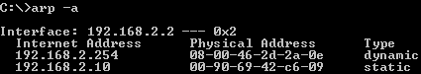
This command is issued on Host A (as shown in the network diagram in the tracert section above). The first entry is dynamic, as it has been discovered using ARP broadcasts. The second is an example of a static entry entered using arp with the -s switch. In this case the IP address 192.168.2.10 was mapped to the MAC address 00-90-69-42-c6-09 by using the following command:
arp -s 192.168.2.10 00-90-69-42-c6-09
Any entry can be deleted by issuing the command arp -d ip_address . By using an * as the ip_address parameter you can delete all entries.
NETSTAT
Netstat displays TCP/IP protocol statistics and information about TCP and UDP connections to and from the local computer. N etstat -a displays the current connections and listening ports:
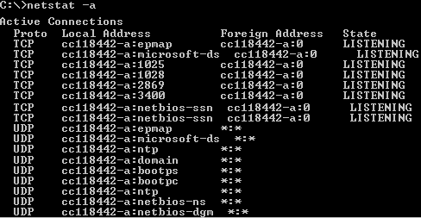
Netstat can also be used to display Ethernet statistics such as the number of bytes sent and received, as well as any dropped network packets, by using the -e switch:
netstat –e
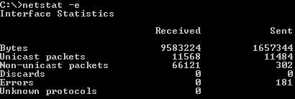
netstat -r produces the same output as the route print command, in other words: displays the contents of the routing table.

NBTSTAT
Nbtstat is used for troubleshooting NetBIOS name resolution problems. It displays protocol statistics and current TCP/IP connections that are using (NBT) NetBIOS over TCP/IP as well as the NetBIOS name table and cache.
To display the NetBIOS name table of the local computer use nbtstat with the -n switch. The status of Registered indicates that the name is registered either by broadcast or with a WINS server. If two hosts on the local network would use the same NetBIOS name, the status would be Conflict .
nbtstat –n
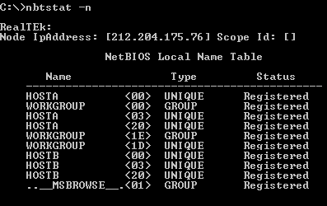
To display the NetBIOS name table of a remote computer use one of the following:
nbtstat -a remotename or nbtstat -A IPaddress
Use nbtstat –c t o display the contents of the local computer NetBIOS name cache.
Use nbtstat -r to display to verify NETBIOS names are correctly resolved by WINS:
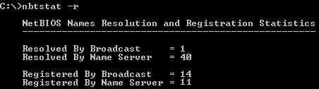

IPCONFIG
Ipconfig can be used on Windows NT, 2000/2003 and XP to display TCP/IP configuration information, renew and release DHCP assigned address configuration, and register in dynamic DNS or flush the local DNS cache. When the ipconfig command is issued without any options the output will be similar to the one below:
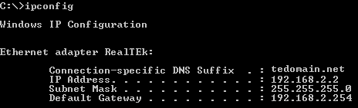
ipconfig /all displays full configuration information, for example:
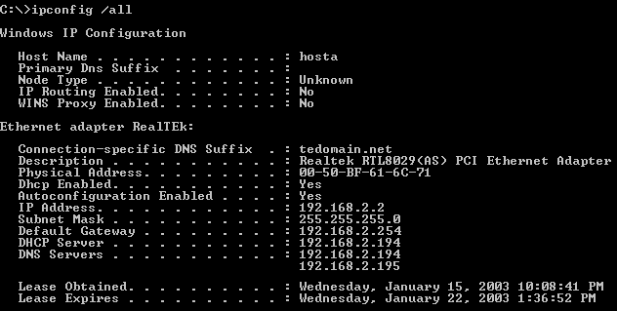
Use ipconfig /release release the IP address configuration.
Use ipconfig /renew Renew the IP address configuration.
ipconfig /flushdns clears the local DNS cache. This is useful when the IP address for a previously resolved host name changed and you want the client to request the IP address fresh from the DNS server rather than the local cache.

IFCONFIG
Ifconfig is a UNIX/Linux command-line utility used to configure and manage network interfaces. Used without any parameters, ifconfig displays the status of all active network adapters:
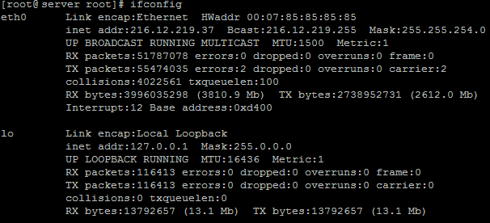
ifconfig –a displays the status of all adapters including those that are down. Ifconfig is the most common command for checking basic information such as the IP address or whether an interface is enabled. The ifconfig command can also be used to configure an interface. The following example shows how to set an IP address and subnet mask for interface eth0:
ifconfig eth0 10.0.0.3 netmask 255.0.0.0
Settings configured in this manner are only kept until the machine is rebooted. To make network settings permanent the changes must be made to the appropriate configuration file in the /etc/sysconfig/network-scripts directory.
Ifconfig can be used with either the up or down parameter to start or stop an interface. The following example disables the first Ethernet interface:
ifconfig eth0 down
WINIPCFG
Winipcfg allows you to display the TCP/IP configuration information and renew and release DHCP assigned address configuration on Windows 9x and ME computers. The screenshot below shows the configuration of an Ethernet adapter with a manually assigned IP address configuration.
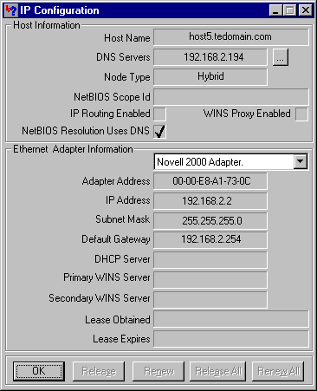
When the configuration would be automatically assigned by a DHCP server, the buttons at the bottom would be enabled allowing you to perform the same tasks as with the ipconfig command. Note that winipcfg is available only on Windows 9x/ME and ipconfig is available on Windows 9x/ME, Windows NT, 2000, 2003, and XP.

NSLOOKUP / DIG
Nslookup displays information you can use to diagnose Domain Name System (DNS) servers and to send DNS queries to DNS servers. Nslookup can be used in interactive or non-interactive mode. In interactive mode, the nslookup command is used without options, to enter a text based console where you can use several sub commands to diagnose DNS. In non-interactive mode, you provide the parameters directly on the command-line after the nslookup command.
Following is an example of the results of running nslookup www.techexams.net (non-interactive mode):
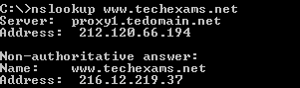
You can use a different DNS server by adding the hostname or IP address of another DNS server, for example:
nslookup www.techexams.net ns2.tedomain.net
Dig is a more advanced utility for diagnosing DNS issues. Originally a UNIX/Linux tool but can be downloaded for Windows as well. It provides numerous options that allow you to control the manual host name lookups and responses. The following screenshot shows the output of running dig www.techexams.net
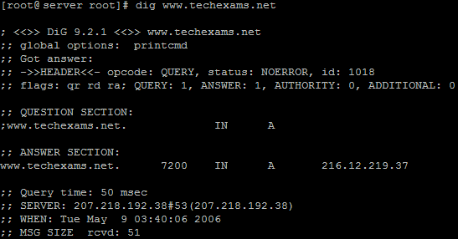

Current TCP/IP utilities related exam objectives for the Network+ exam.
4.1 Given a troubleshooting scenario, select the appropriate network utility from the following:
- Tracert / traceroute
- Ping
- Arp
- Netstat
- Nbtstat
- Ipconfig / ifconfig
- Winipcfg
- Nslookup /Dig
4.2 Given output from a network diagnostic utility (For example: those utilities listed in objective 4.1), identify the utility and interpret the output.

